Media Alert
FOR RELEASE –– June 1, 2018

Corning Presents First Annual ‘Corning Leadership in Glass Award’ at ECTC 2018

CORNING, N.Y. — Corning Incorporated (NYSE: GLW) announced today that a team led by researchers at Georgia Institute of Technology was presented the first annual “Corning Leadership in Glass Award.”

Dr. Rao Tummala, distinguished professor of electrical and computer engineering at Georgia Tech, accepted the inaugural award recently at a reception hosted by Corning at the 2018 Electronic Components and Technology Conference (ECTC) in San Diego, California.

“We’re pleased to accept this award from Corning,” said Tummala. “We have long believed that the properties of glass make it the next best material of choice for semiconductor manufacturing processes after silicon, and we’re proud that the research we’ve done in panel-level fan-out, in particular, is gaining more acceptance.”

The award recognized the technical paper submitted at ECTC 2017 that best demonstrated the viability of glass for semiconductor packaging applications. It was chosen by Corning technologists from among 20 technical papers shared by the IEEE Electronics Packaging Society.

The paper, “Design and Demonstration of Highly Miniaturized, Low Cost Panel-Level Glass Package for MEMS Sensors,” was written by Chintan Buch, Daniel Struk, Klaus-Jürgen Wolter, Peter J. Hesketh, Venky Sundaram, and Dr. Tummala representing Georgia Tech, as well as Catherine Shearer and James Haley from EMD-Performance Materials, Mel Findlay of KWJ Engineering Incorporated, and Marc Papageorge of SPEC Sensors, LCC.
“This award demonstrates Corning’s belief that glass is emerging as a strong and viable material solution in semiconductor applications,” said Rustom Desai, commercial operations director of Corning Precision Glass Solutions. “We see significant industry pull for the use of glass as a high-performance, cost-effective substrate for advanced packaging methods.”

Also at ECTC 2018, Dr. Aric Shorey, Corning Precision Glass Solutions commercial technology manager, and Dr. Jingshi Wu, Corning Glass Technologies senior research scientist, led a professional development course called, “Fundamentals of Glass and Applications for Advanced Semiconductor Packaging.”

Precision Glass Solutions is a newly created business unit within Corning that combines multiple, long-standing specialty glass capabilities. These include proprietary manufacturing platforms, finishing processes, best-in-class metrology instruments, automated laser glass-cutting tools, and optical design expertise. This business was created specifically to address the emerging requirements for glass across micro-electronics.
Learn more about Corning Precision Glass Solutions here:
http://www.corning.com/precision-glass-solutions

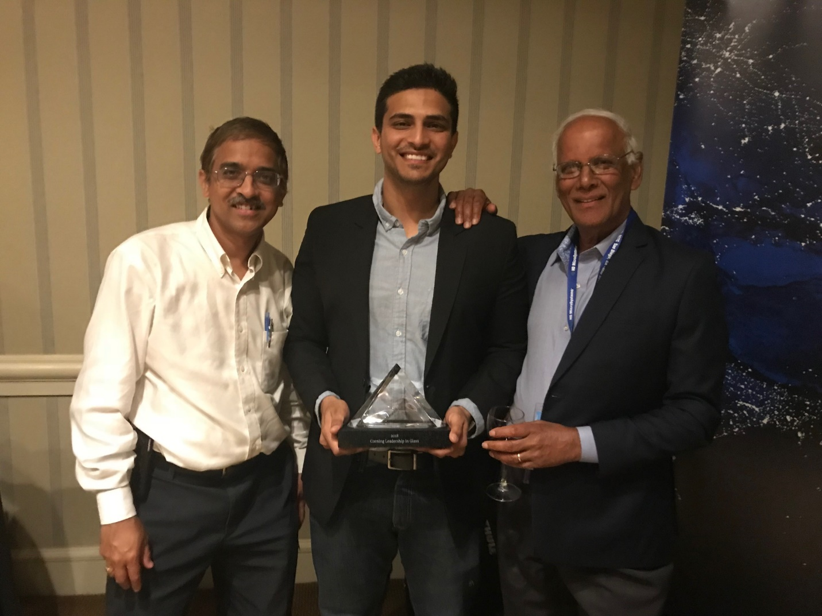
Venky Sundaram, Chintan Buch, and Rao Tummala (left to right) accept the inaugural ‘Corning Leadership in Glass Award’ at ECTC 2018.
About Corning Incorporated
Corning (www.corning.com) is one of the world's leading innovators in materials science, with a more than 165-year track record of life-changing inventions. Corning applies its unparalleled expertise in glass science, ceramic science, and optical physics along with its deep manufacturing and engineering capabilities to develop category-defining products that transform industries and enhance people's lives. Corning succeeds through sustained investment in RD&E, a unique combination of material and process innovation, and deep, trust-based relationships with customers who are global leaders in their industries.
Corning's capabilities are versatile and synergistic, which allows the company to evolve to meet changing market needs, while also helping our customers capture new opportunities in dynamic industries. Today, Corning's markets include optical communications, mobile consumer electronics, display technology, automotive, and life sciences vessels. Corning's industry-leading products include damage-resistant cover glass for mobile devices; precision glass for advanced displays; optical fiber, wireless technologies, and connectivity solutions for state-of-the-art communications networks; trusted products to accelerate drug discovery and delivery; and clean-air technologies for cars and trucks.
Media Relations Contact:

Kaitlin Cutler
cutlerk@corning.com
+1 607-974-5331

Follow Corning:
LinkedIn | Facebook | Twitter | YouTube

